**Hotel Reservation Cancellation Analysis Report**

Executive Summary

**Business Challenge:** City Hotel and Resort Hotel have experienced significantly high cancellation rates in recent years, resulting in reduced revenues and suboptimal hotel room utilization. This comprehensive analysis examines the factors contributing to booking cancellations and provides strategic recommendations to minimize cancellation rates and optimize revenue generation.

Our analysis reveals that **37% of all reservations are cancelled**, representing approximately 46,000 cancelled bookings out of 119,000 total reservations. The primary objective is to identify actionable strategies to reduce these cancellation rates and improve overall business efficiency.

Research Questions

* What are the key variables that influence hotel reservation cancellations?
* How can hotels implement effective strategies to reduce cancellation rates?
* What pricing and promotional strategies will optimize revenue while minimizing cancellations?

Research Hypotheses

* Higher room prices correlate with increased cancellation rates
* Extended booking lead times result in higher cancellation frequencies
* Most reservations originate from offline travel agents

Key Assumptions

* No extraordinary events between 2015-2017 significantly impacted the dataset
* Historical data remain relevant for current strategic planning
* No adverse consequences from implementing recommended strategies
* Hotels are not currently utilizing the proposed solutions
* Booking cancellations represent the primary factor affecting revenue efficiency

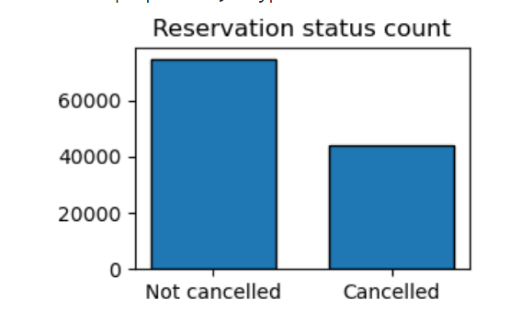

*The data reveals that while the majority of reservations are confirmed, the 37% cancellation rate significantly impacts hotel revenue and operational efficiency.*

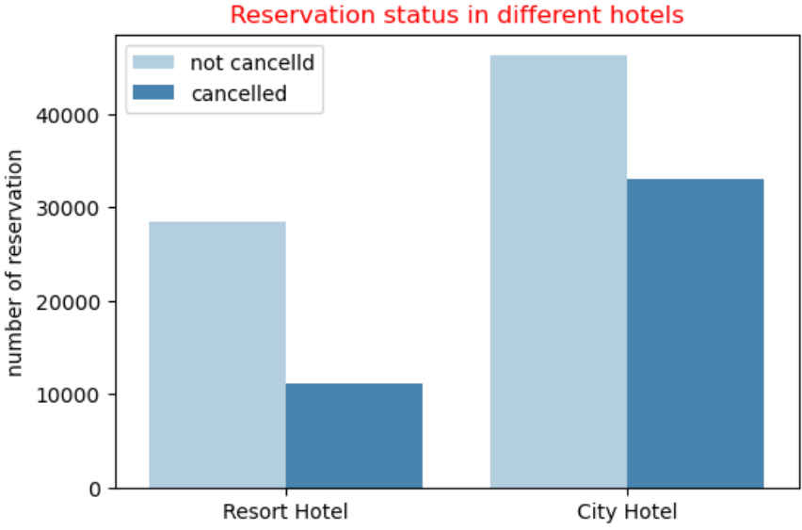

*City hotels demonstrate higher total booking volumes but also experience elevated cancellation rates compared to resort hotels, likely due to pricing differentials and booking behaviour patterns.*

Key Finding:

City hotels generate significantly higher booking volumes than resort hotels, potentially due to lower average daily rates. However, this volume advantage is offset by proportionally higher cancellation rates.

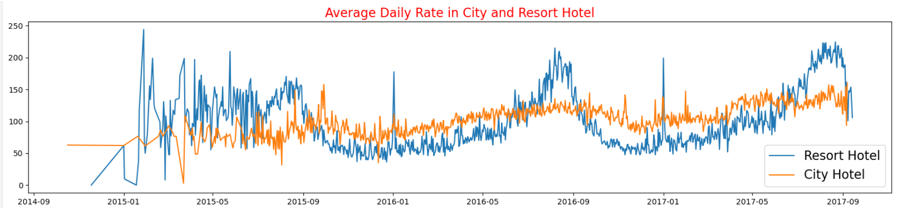

*Resort hotels command premium rates during peak seasons and weekends, while city hotels maintain more consistent pricing throughout the year with occasional rate fluctuations*

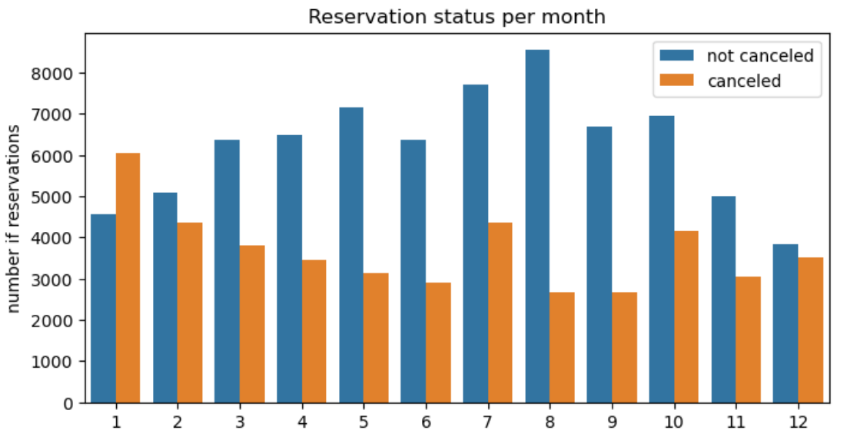

*Peak booking activity occurs during July-September, with August showing the highest overall reservation volume. January exhibits notable cancellation patterns that require strategic intervention*.

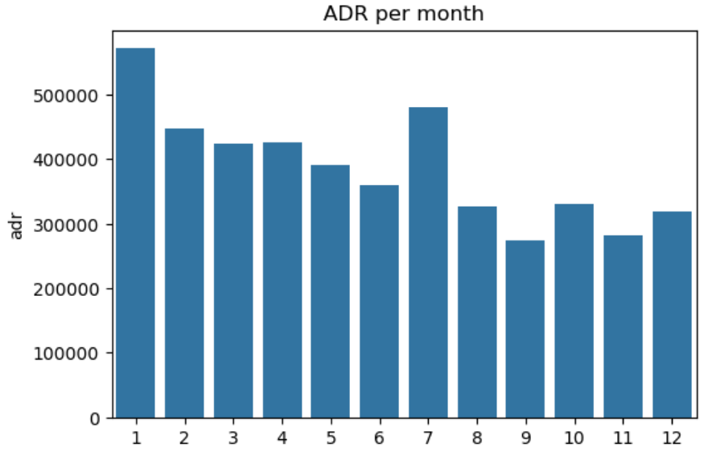

**Key Finding: Price-Cancellation Correlation**

Our analysis confirms a strong positive correlation between room rates and cancellation probability. Higher average daily rates directly correspond to increased cancellation frequencies, validating our primary hypothesis

**Geographic Distribution Analysis**

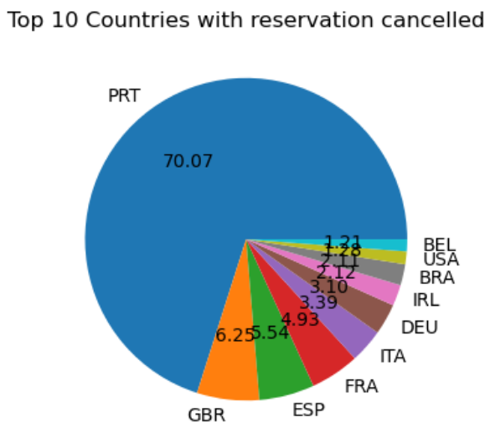

**Key Finding: Geographic Concentration**

Portugal dominates cancellation statistics with 70.07% of all cancellations, indicating a critical need for targeted quality improvement and customer retention strategies in this market.

Strategic Recommendations

* **Dynamic Pricing Strategy Implementation:** Develop sophisticated pricing algorithms that balance revenue optimization with cancellation risk. Implement location-specific pricing strategies and offer strategic discounts during high-cancellation periods to maintain occupancy rates while preserving revenue.
* **Hotel Type-Specific Revenue Management:** Resort hotels should implement weekend and holiday discount strategies to improve their cancellation-to-confirmation ratio. City hotels should focus on value-added packages to justify premium pricing and reduce price sensitivity.
* **Seasonal Campaign Optimization:** Launch targeted marketing campaigns in January with competitive pricing and value propositions to counteract the month's historically high cancellation rates. Develop retention-focused strategies during peak booking months (July-September).
* **Geographic Market Prioritization:** Implement quality improvement initiatives specifically targeting the Portuguese market, which accounts for 70% of cancellations. Develop region-specific retention programs and enhance service standards to address market-specific concerns.
* **Direct Booking Channel Development:** Invest in direct booking platform enhancement and customer loyalty programs to reduce dependency on online travel agencies and improve profit margins while potentially reducing cancellation rates through better customer relationships.

Conclusions and Future Outlook

This comprehensive analysis of hotel reservation data from 2015-2017 confirms a strong correlation between pricing strategies and cancellation rates. The 37% overall cancellation rate represents a significant revenue optimization opportunity, with strategic interventions potentially improving both occupancy rates and customer satisfaction. The concentration of cancellations in specific geographic markets (particularly Portugal) and the dominance of online travel agencies in the booking ecosystem provide clear strategic focal points for improvement initiatives. Implementation of the recommended pricing, marketing, and quality enhancement strategies should result in measurable improvements in cancellation rates and overall revenue performance. Continued monitoring of these key performance indicators, combined with regular analysis of booking patterns and customer behavior, will enable both hotels to maintain competitive advantage while optimizing revenue generation in an increasingly dynamic hospitality market.